Name

Roll No

SAP ID

Branch

Batch

**Experiment No. 1**

Write a program to swap two variables values with and without using third variables. Write algorithm and draw flowchart for the same.

**Aim :**

Swapping of two number without using third variable

**Algorithm :**

STEP 1: START

STEP 2: ENTER a, b

STEP 3: PRINT a, b

STEP 4: a = a + b

STEP 5: b= a - b

STEP 6: a =a - b

STEP 7: PRINT a, b

STEP 8: END

**Flowchart :**

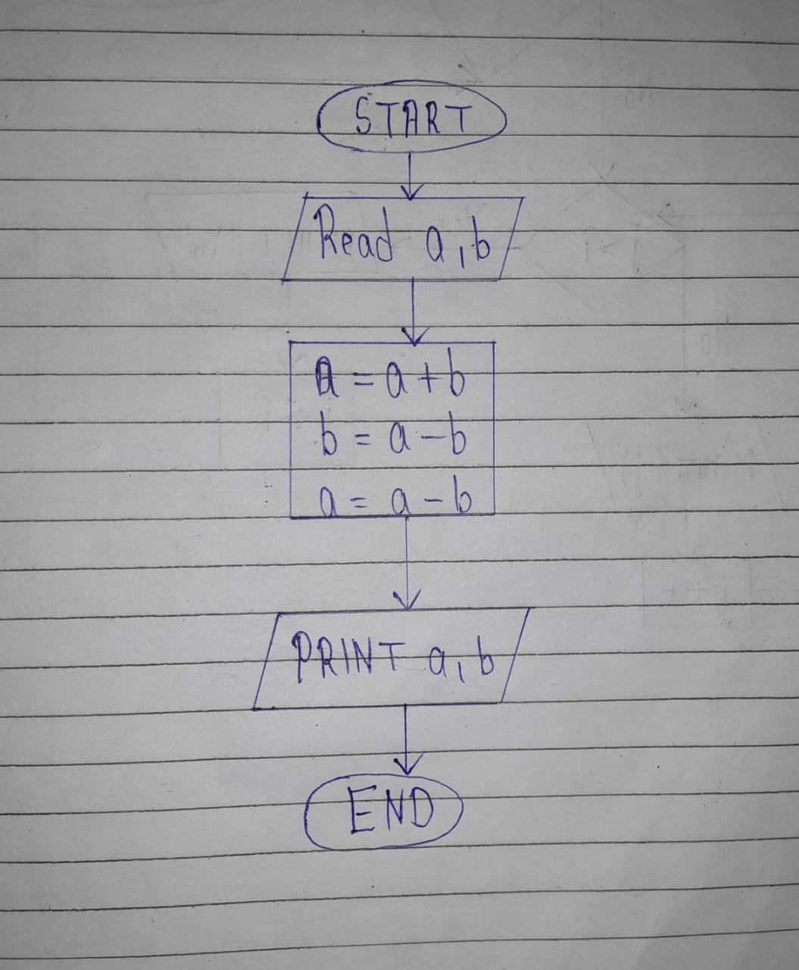

**Code :**

#include<stdio.h>

#include<conio.h>

void main()

{

int a,b;

clrscr();

printf("Enter a and b:\n");

scanf("%d %d",&a,&b);

a=a+b;

b=a-b;

a=a-b;

printf("\n After Swapping\n a and b is %d and %d respectively",a,b);

getch();

}

**Output :**

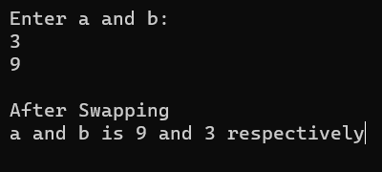

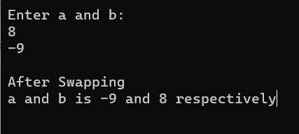

**Experiment No. 2**

Write a program to check odd or even number: (a) using modulus operator (b) using conditional operator.

**Aim:**

Check odd or even number

**A ) Using modulus operator**

**Code :**

#include<stdio.h>

#include<conio.h>

void main()

{

int num;

clrscr();

printf("Enter your number:\n");

scanf("%d",&num);

if(num%2==0)

printf("\n%d is EVEN NUMBER",num);

else

printf("\n%d is ODD NUMBER",num);

getch();

}

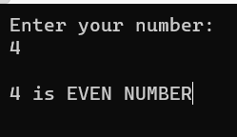**Output :**

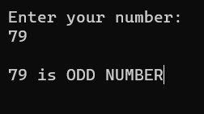

**B ) Using conditional operator**

**Code :**

#include<stdio.h>

#include<conio.h>

void main()

{

int num;

//clrscr();

printf("Enter your number:\n");

scanf("%d",&num);

(num%2==0)?printf("\n%d is EVEN NUMBER",num):printf("\n%d is ODD NUMBER",num);

getch();

}

**Output :**

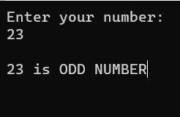

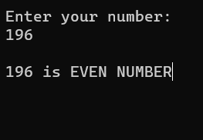

**Experiment No. 3**

Design and develop a C program to read a year as an input and find whether it is leap year or not. Also consider the end of the centuries. Write algorithm and draw flowchart for the same.

**Aim :**

Check Leap year or not

**Algorithm :**

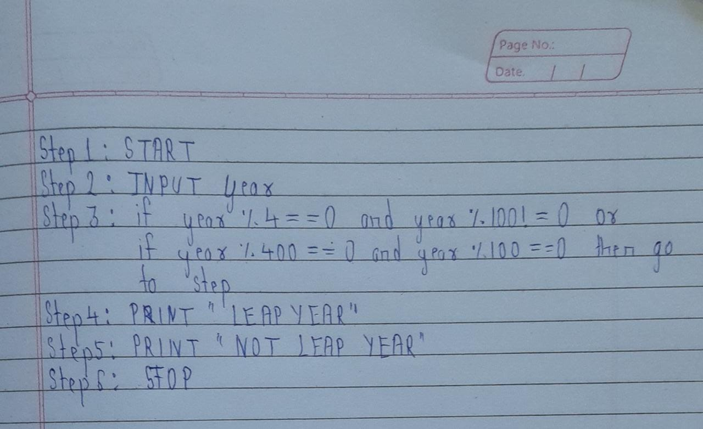

**Flowchart :**

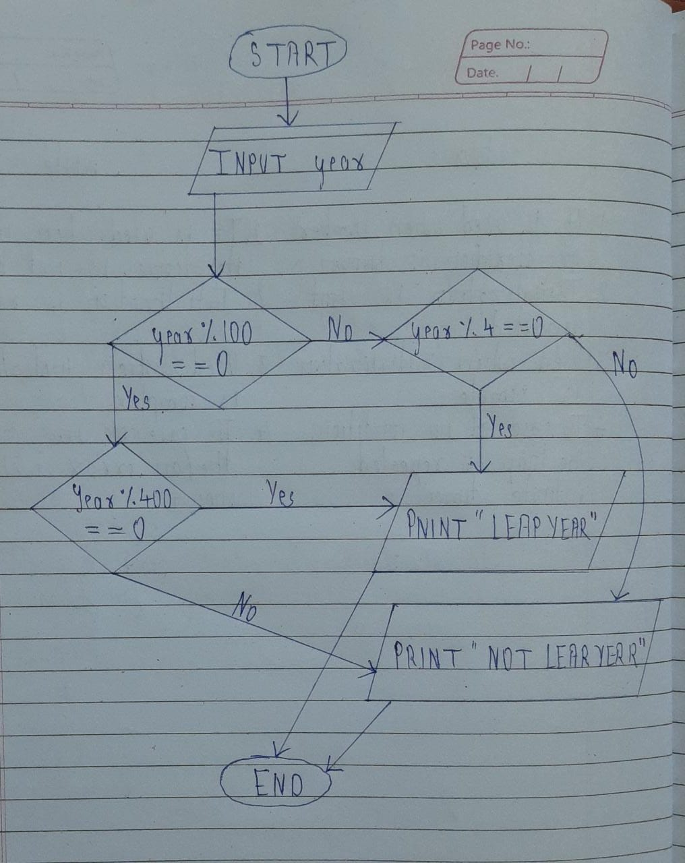

**Code :**

#include<stdio.h>

#include<conio.h>

void main()

{

int year;

//clrscr();

printf("Enter your year:\n");

scanf("%d",&year);

if((year%100==0 && year%400==0) || (year%100!=0 && year%4==0))

printf("\n%d is LEAP YEAR",year);

else

printf("\n%d is NOT LEAP YEAR",year);

getch();

}

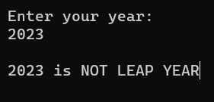**Output :**

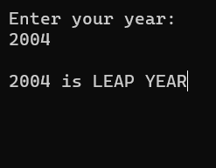

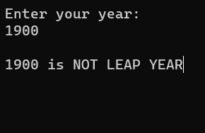

**Experiment No. 4**

Write a C program to find the sum of individual digits of a 3-digit number.

**Aim** :

sum of individual digits of a 3-digit number

**Code :**

#include<stdio.h>

#include<conio.h>

void main()

{

int num,sum=0,rem;

//clrscr();

printf("Enter your number:\n");

scanf("%d",&num);

while(num>0)

{

rem=num%10;

sum+=rem;

num/=10;

}

printf("\nSum of individual digit number is %d",sum);

getch();

}

**Output:**

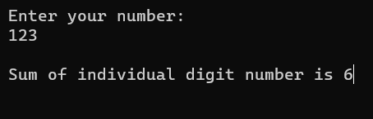 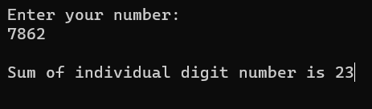

**Experiment No. 5**

Design and develop a flowchart or an algorithm that takes three coefficients (a, b, and c) of a Quadratic equation (ax2 +bx+c=0) as input and compute all possible roots. Implement a C program for the developed flowchart/algorithm and execute the same to output the possible roots for a given set of coefficients with appropriate messages.

**Aim :**

To find roots of a Quadratic equation

**Algorithm :**

Step 1:Start.

Step 2:Read a, b, c values.

Step 3:Compute d = b2 4ac.

Step 4:if d > 0 then. r1 = b+ sqrt (d)/(2*a) r2 = b sqrt(d)/(2*a)

Step 5:Otherwise if d = 0 then. compute r1 = -b/2a, r2=-b/2a. print r1,r2 values.

Step 6:Otherwise if d < 0 then print roots are imaginary.

Step 7:Stop.

**Flowchart :**

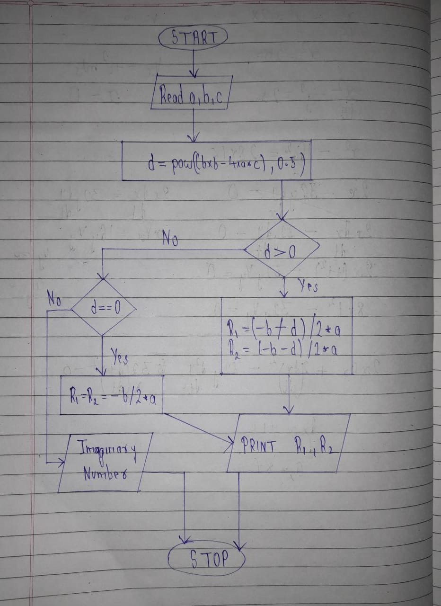

**Code :**

#include<stdio.h>

#include<conio.h>

#include<math.h>

void main()

{

double a,b,c,discriminant,root1,root2,real,img;

//clrscr();

//ax^2 + bx + c = 0

printf("Enter a value:\n");

scanf("%lf",&a);

printf("\nEnter b value:\n");

scanf("%lf",&b);

printf("\nEnter c value:\n");

scanf("%lf",&c);

discriminant=b*b-4*a*c;

if(discriminant==0)

{

root1=root2=-b/(2*a);

printf("\nRoots of an equation is %0.3lf",root1);

}

else if(discriminant>0)

{

root1=(-b+sqrt(discriminant)/(2*a));

root2=(-b-sqrt(discriminant)/(2*a));

printf("\nRoots of an equation is %0.3lf and %0.3lf",root1,root2);

}

else if(discriminant<0)

{

real=-b/(2*a);

img=sqrt(-(discriminant))/(2*a);

printf("\nRoots of an equation is %0.3lf + i%0.3lf and %0.3lf - i%0.3lf",real,img,real,img);

}

else

printf("\nEnter valid number");

getch();

}

**Output :**

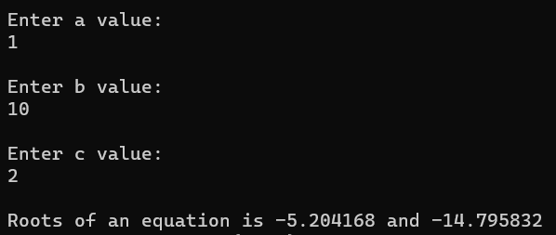

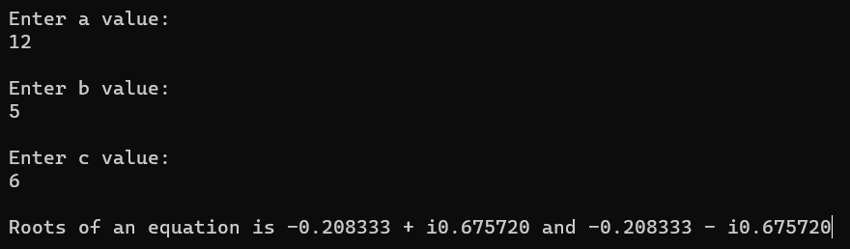

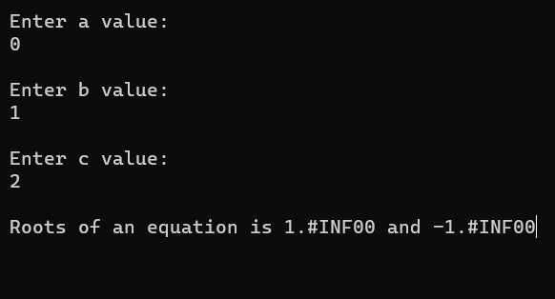

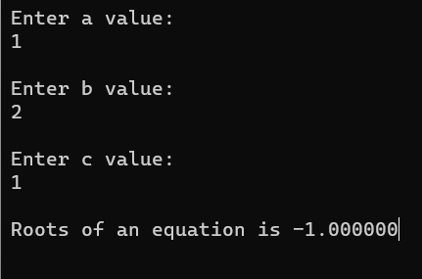

**Experiment No. 6**

Write a program to count the number of digits in a given integer.

**Aim :**

Counting the number of digits in a given integer.

**Code :**

#include<stdio.h>

#include<conio.h>

void main()

{

int num,count=0,rem;

//clrscr();

printf("Enter your number:\n");

scanf("%d",&num);

while(num>0)

{

count++;

num=num/10;

}

printf("\n Total number of digits in given number: %d",count);

getch();

}

**Output :**

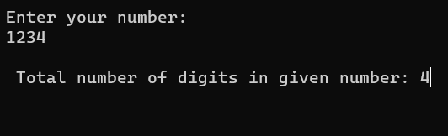

**Experiment No. 7**

Write a menu driven program to perform simple arithmetic operations based on the user's choice. The user will indicate the operation to be performed using the signs e.g. + for addition, etc. Write an algorithm and draw flowchart for same.

**Aim :** Use of switch in making simple calculator

**Algorithm :**

1.START

2.PRINT “MENU ADDITION SUBSTRACTION MULTIPLICATION DIVISION”

3.PRINT “enter your choice”

4.INPUT choice

5.CHECK:

6.IF (choice>=1 && choice<=4) then

7. PRINT “enter two numbers”

8. INPUT n1 and n2

9, SWITCH (choice)

10. case 1:

Res=n1+n2

Print res

break

11. case 2:

If(n1>n2)

Res=n1-n2

Print res

Else

Res=n2-n1

Print res

break

12. case 3:

Res=n1*n2

Print res

break

13. case 4:

If (n2! =0)

Res=n1/n2

Print res

break

14. default:

Print “invalid choice”

15.END

**Flowchart :**

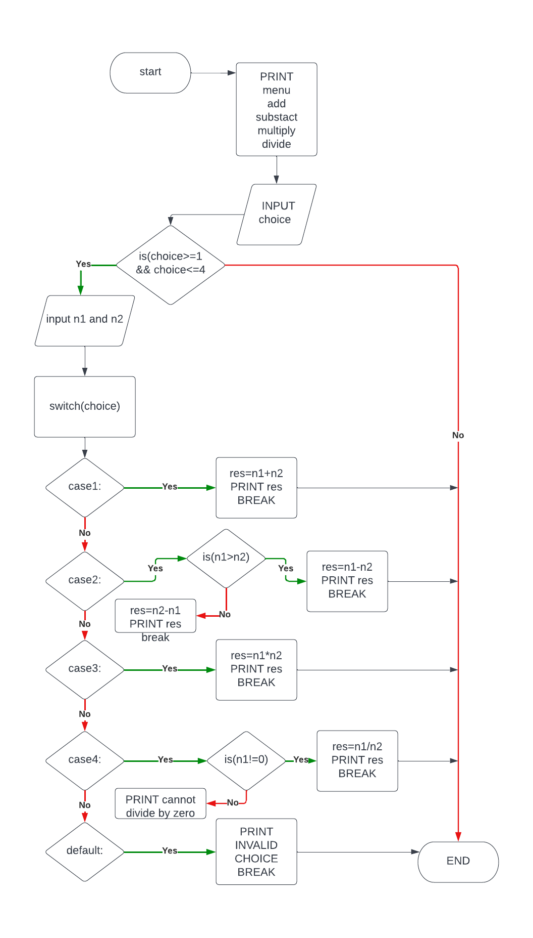

**Code :**

#include<stdio.h>

#include<conio.h>

void main()

{

int n1,n2;

char choice;

//clrscr();

printf("Menu of Simple calculator\n");

printf("+. Addition\n-. Subtraction\n*. Multiplication\n/. Division");

printf("\nEnter your choice according to the Menu:\n");

scanf("%c",&choice);

printf("\nEnter two number:\n");

scanf("%d %d",&n1,&n2);

switch(choice)

{

case '+':

printf("\nAddition of two number is %d",n1+n2);

break;

case '-':

printf("\nSubtraction pof two number is %d",n1-n2);

break;

case '*':

printf("\nMultiplication of two number is%d",n1*n2);

break;

case '/':

printf("\nDivision of two number is %d",n1/n2);

break;

default:

printf("\nEnter valid number");

}

getch();

}

**Output :**

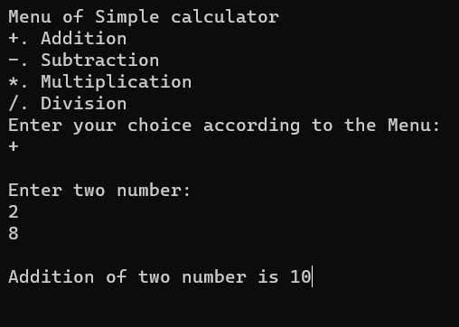

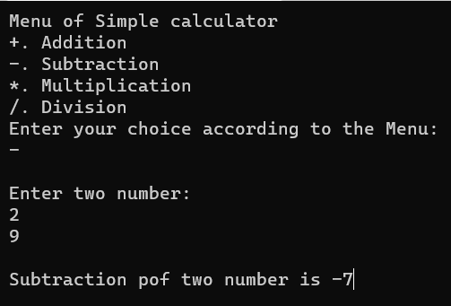

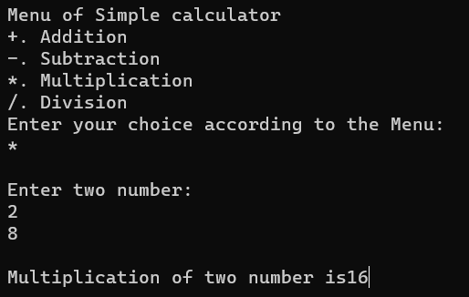

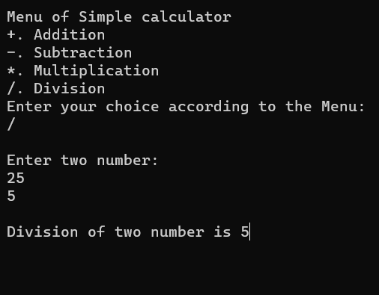

**Experiment No. 8**

Write a program to read a number of more than one digit, reverse the number and display the sum of digits of numbers. Write algorithm and draw flowchart for the same.

**Aim :**

reverse the number and display the sum of digits of numbers

**Algorithm :**

1. Ask the user to enter any number.
2. Declare and initialize another variable reversed with 0, where reversed an integer variable.
3. Get the reminder of the given number by performing the modulo division (%) and store the value in rem variable, likey rem= number % 10.
4. Multiply reversed by 10 and add rem, like reversed = reversed*10 + rem and sum=sum + rem.
5. Divide numbered by 10, like numbered/10.
6. Repeat the steps 3 to 5 till numbered is not equal to (or greater than) zero.

**Flowchart :**

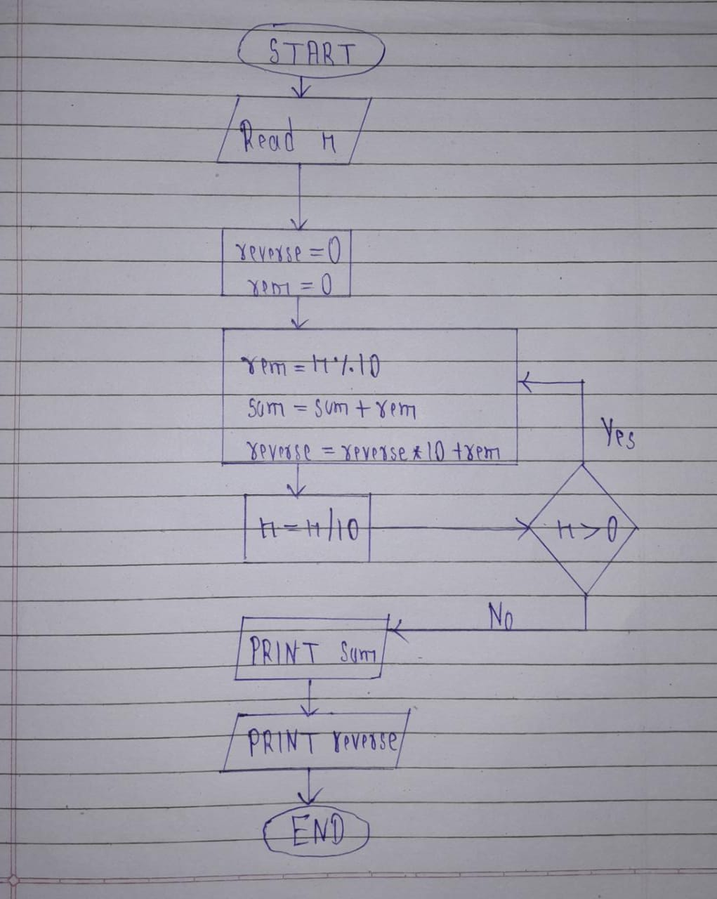

**code :**

#include<stdio.h>

#include<conio.h>

void main()

{

int num,rem,reverse=0,sum=0;

//clrscr();

printf("Enter a number:\n");

scanf("%d",&num);

while(num>0)

{

rem=num%10;

sum+=rem;

reverse=reverse*10+rem;

num/=10;

}

printf("\nAfter Reversing a number:\n%d",reverse);

printf("\nSum of all digit of a number:\n%d",sum);

getch();

}

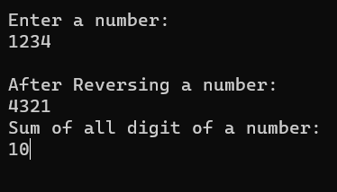**Output :**

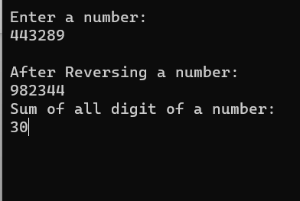

**Experiment No. 9**

Write programs to display each of the following patterns. Write algorithm and draw flowchart for the same

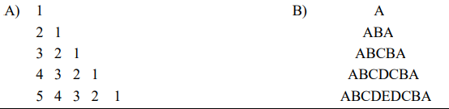

**Aim :**

study of pattern using loop

**Algorithm :**

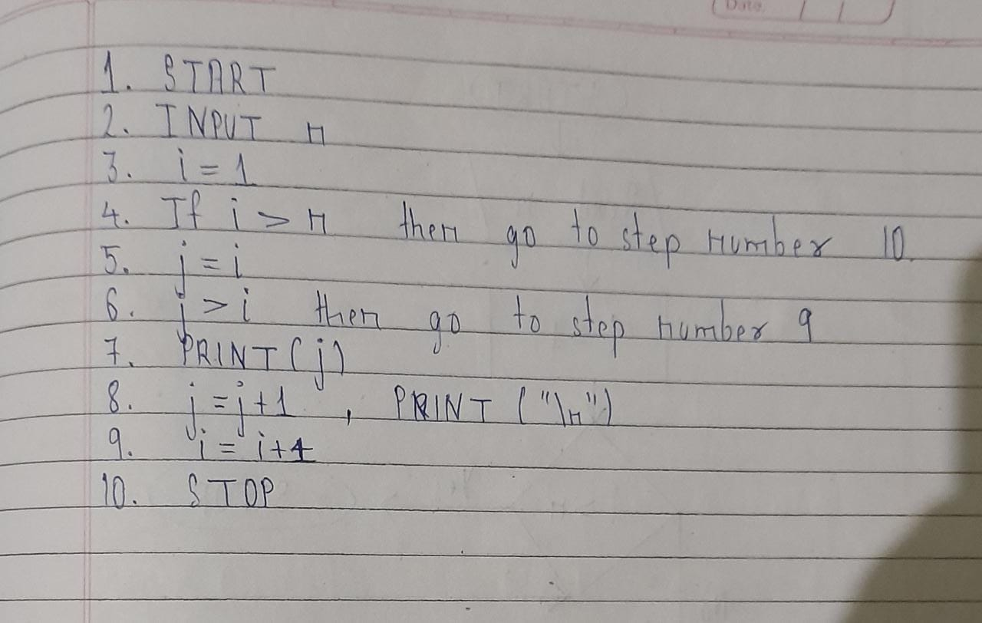

**Flowchart :**

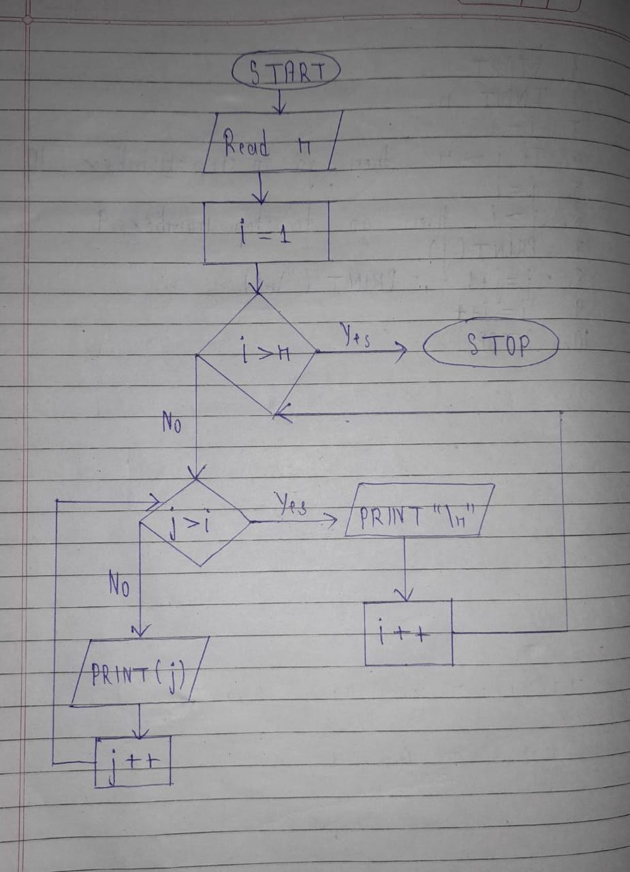

**Code :**

#include<stdio.h>

#include<conio.h>

void main()

{

int i,j,n;

//clrscr();

printf("Enter your n:\n");

scanf("%d",&n);

for(i=1;i<=n;i++)

{

for(j=i;j>=1;j--)

{

printf("%d ",j);

}

printf("\n");

}

}

**Output :**

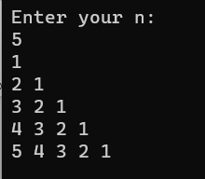

**B)**

**Algorithm :**

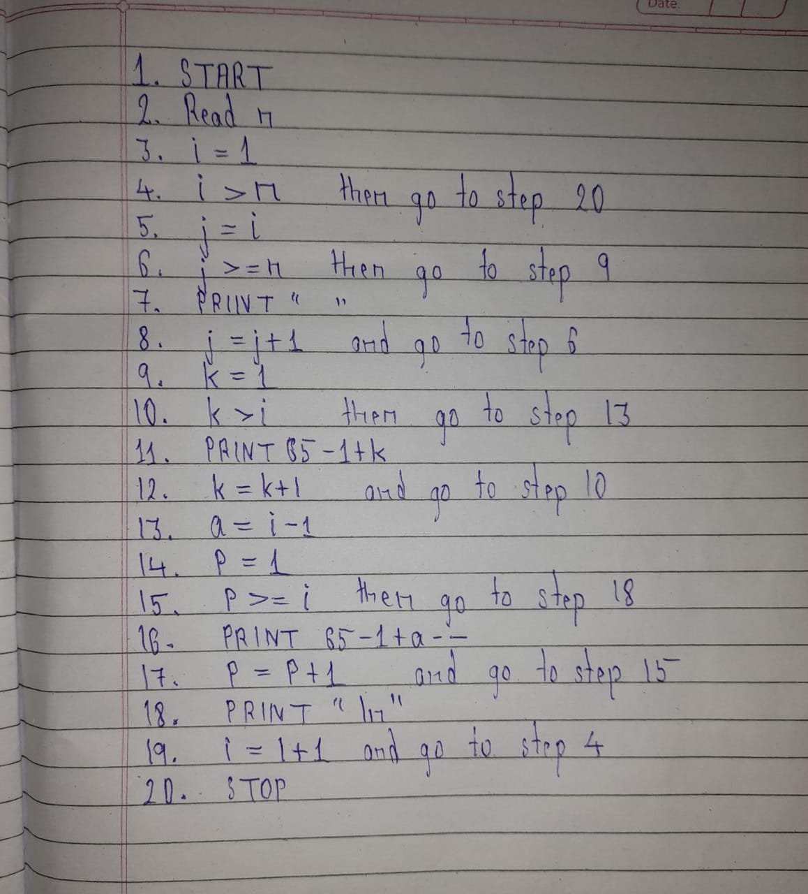

**Flowchart :**

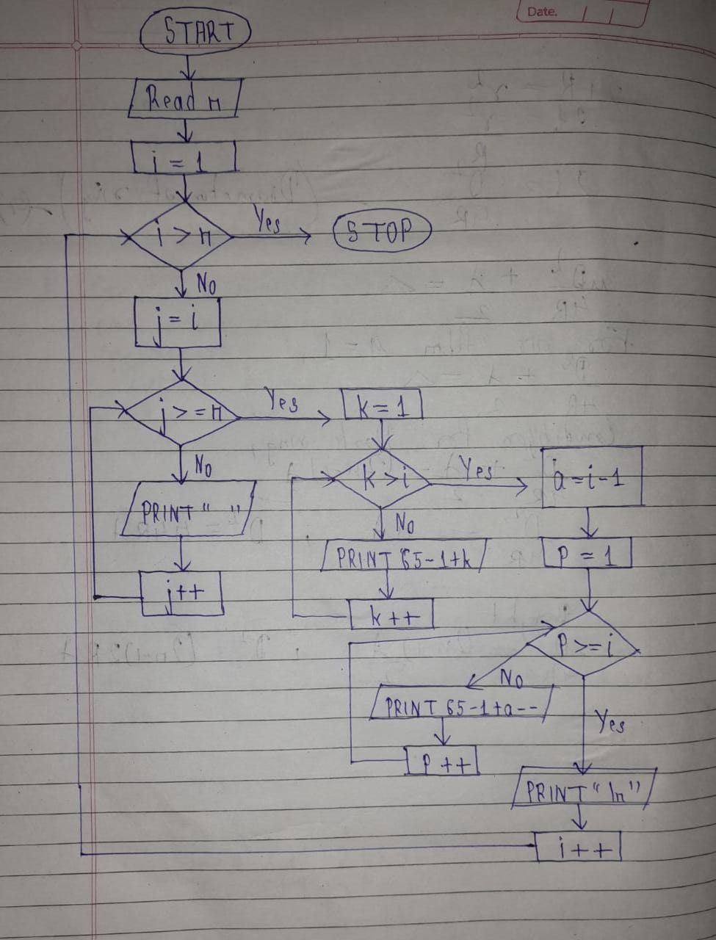

**Code :**

#include<stdio.h>

#include<conio.h>

void main()

{

int i,j,n,k,a,p;

//clrscr();

printf("Enter rows:\n");

scanf("%d",&n);

for(i=1;i<=n;i++)

{

for(j=i;j<n;j++)

{

printf(" ");

}

for(k=1;k<=i;k++)

{

printf("%c",65-1+k);

}

a=i-1;

for(p=1;p<i;p++)

{

printf("%c",65-1+a--);

}

printf("\n");

}

getch();

}

**Output:**

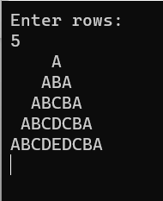

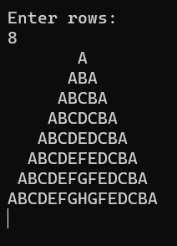

**Experiment No. 10**

Write a C program to find maximum and minimum between two numbers using functions. Write algorithm and draw flowchart for the same.

**Aim :**

Study of function

**Algorithm :**

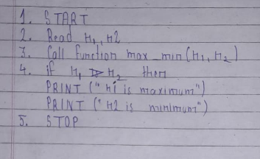

**Flowchart :**

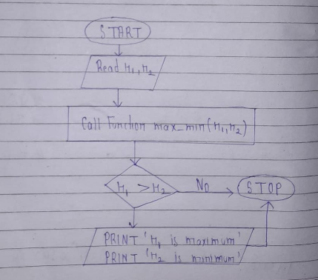

**Code :**

#include<stdio.h>

#include<conio.h>

void max_min(int n1,int n2);

void main()

{

int n1,n2;

//clrscr();

printf("Enter two number:\n");

scanf("%d %d",&n1,&n2);

max_min(n1,n2);

getch();

}

void max_min(int n1,int n2)

{

if(n1>n2)

printf("\n%d is maximum",n1);

printf("\n%d is minimum",n2);

}

**Output:**

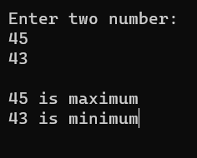

**Experiment No. 11:**

Write C program to find GCD of two integers by using recursive function. Write algorithm and draw flowchart for the same.

**Aim :** To find GCD of two integers by using recursive function

**Algorithm :**

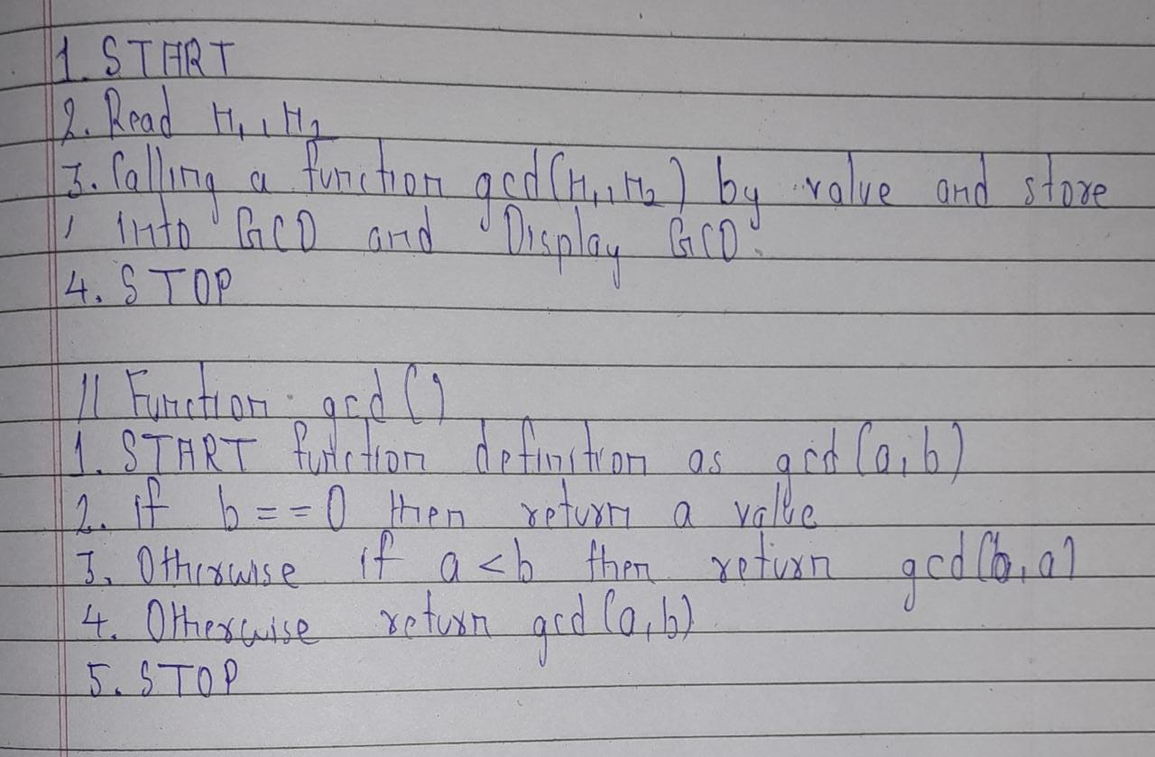

**Flowchart :**

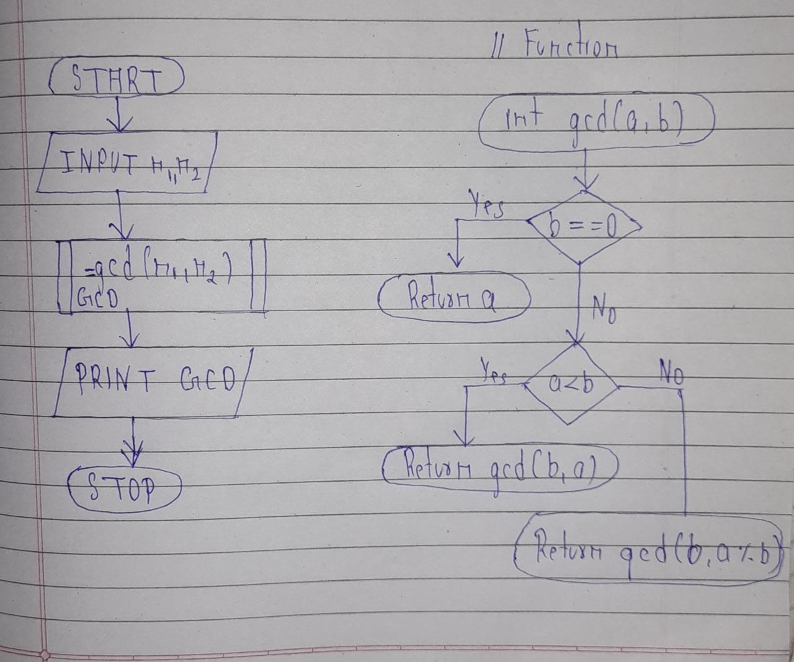

**Code :**

#include<stdio.h>

#include<conio.h>

int gcd(int a,int b)

{

if(b==0)

return a;

else{

if(a<b)

return gcd(b,a);

else

return gcd(b,a%b);

}

}

void main()

{

int n1,n2,GCD;

//clrscr();

printf("Enter your two number :\n");

scanf("%d %d",&n1,&n2);

GCD=gcd(n1,n2);

printf("GCD of %d and %d is %d",n1,n2,GCD);

getch();

}

**Output:**

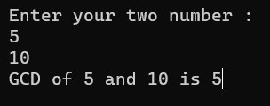

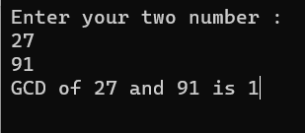

**Conclusion :**

We learn the recursive function through this example .And also the importance of recursive function in a program of GCD.

**Experiment 12 :**

Write a C program to find both the largest and smallest number in a list of integers. Write algorithm and draw flowchart for the same.

**Aim :**

To find largest and smallest number in a list of integers.

**Algorithm :**

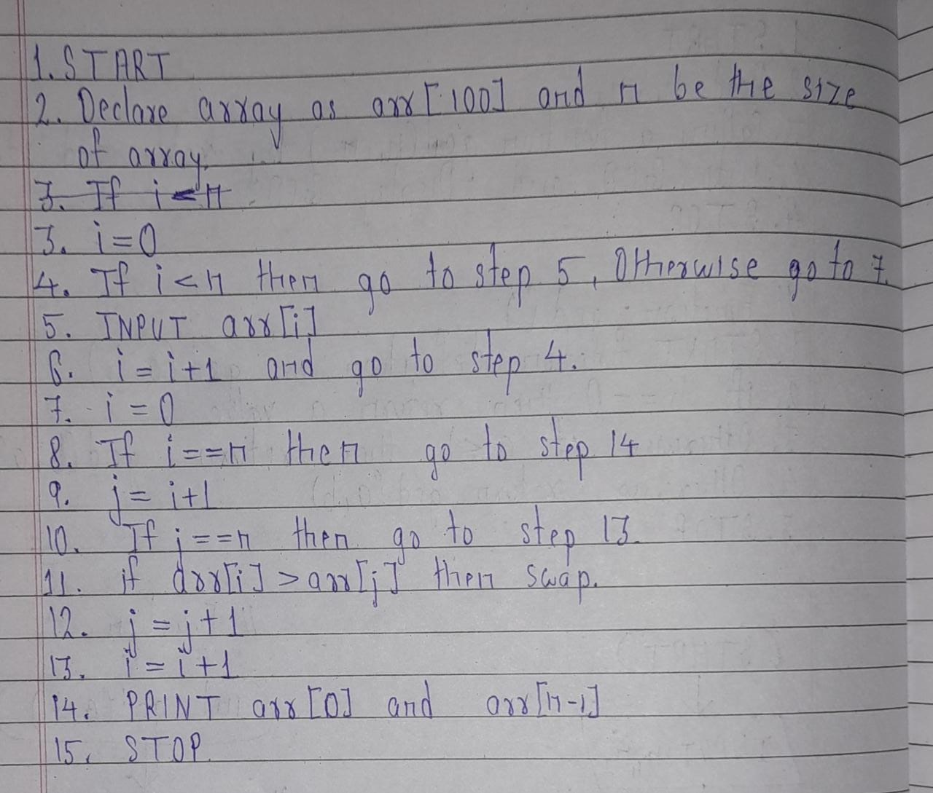

**Flowchart :**

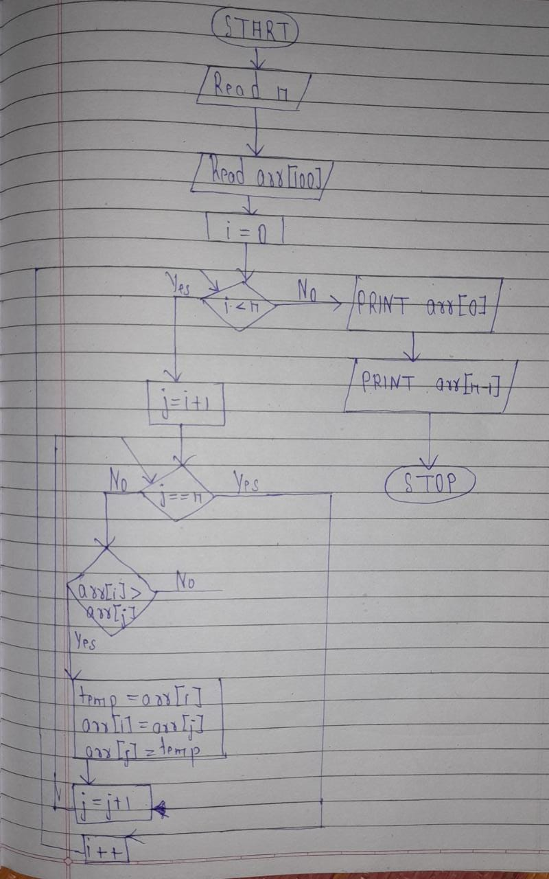

**Code :**

#include<stdio.h>

#include<conio.h>

void main()

{

int i,j,arr[90],n,temp=0;

//clrscr();

printf("Enter array size:\n");

scanf("%d",&n);

printf("Enter array element:\n");

for(i=0;i<n;i++)

{

scanf("%d",&arr[i]);

}

printf("\nPrinting array:\n");

for(i=0;i<n;i++)

{

printf("%d ",arr[i]);

}

for(i=0;i<n;i++)

{

for(j=i+1;j<n;j++)

{

if(arr[i]>arr[j]){

temp=arr[i];

arr[i]=arr[j];

arr[j]=temp;

}

}

}

printf("\nSmallest element from list is :%d",arr[0]);

printf("\nLargest element from list is %d",arr[n-1]);

getch();

}

**Output :**

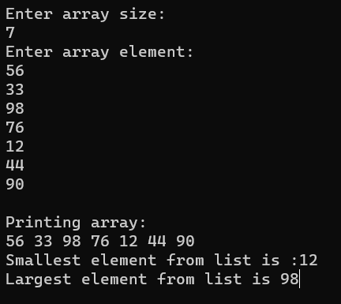

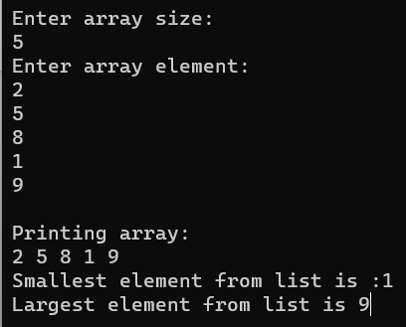

**Conclusion :**

Due to this program we aware of array and it’s important in day to day life. Array is a collection of element of same data type .

**Experiment 13 :**

Develop, implement and execute a C program that reads two matrices A (m x n) and B (p x q) and Compute product of matrices A and B. Read matrix A and matrix B in row major order and in column major order respectively. Print both the input matrices and resultant matrix with suitable headings and output should be in matrix format only.

**Aim :**

Study of matrix and 2D array.

**Code :**

#include<stdio.h>

#include<conio.h>

void input_print_matrix(int matrix[10][10],int row,int col)

{

int i,j;

printf("\nEnter matrix element :\n");

for(i=0;i<row;i++)

{

for(j=0;j<col;j++)

{

scanf("%d",&matrix[i][j]);

}

}

printf("\nPrinting matrix :\n");

for(i=0;i<row;i++)

{

for(j=0;j<col;j++)

{

printf("%d ",matrix[i][j]);

}

printf("\n");

}

}

void main()

{

int i,j,k,row1,col1,row2,col2,sum,m1[10][10],m2[10][10],m3[10][10];

//clrscr();

printf("\nEnter row and column of matrix 1:\n");

scanf("%d %d",&row1,&col1);

printf("\nEnter row and column of matrix 2:\n");

scanf("%d %d",&row2,&col2);

if(col1==row2)

{

input_print_matrix(m1,row1,col1);

//print_matrix(m1,row1,col1);

input_print_matrix(m2,row2,col2);

//print_matrix(m2,row2,col2);

printf("\nMultiplication of two matrix is:\n");

for(i=0;i<row1;i++)

{

for(j=0;j<col2;j++)

{

sum=0;

for(k=0;k<row1;k++)

{

sum=sum+m1[i][k]+m2[k][j];

}

m3[i][j]=sum;

}

}

for(i=0;i<row1;i++)

{

for(j=0;j<col2;j++)

{

printf("%d ",m3[i][j]);

}

printf("\n");

}

}

else

printf("\nMultiplication not possible ...");

getch();

}

**Output :**

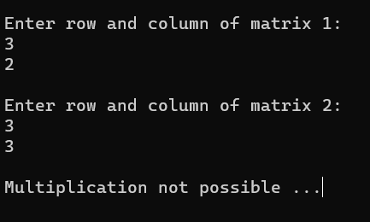

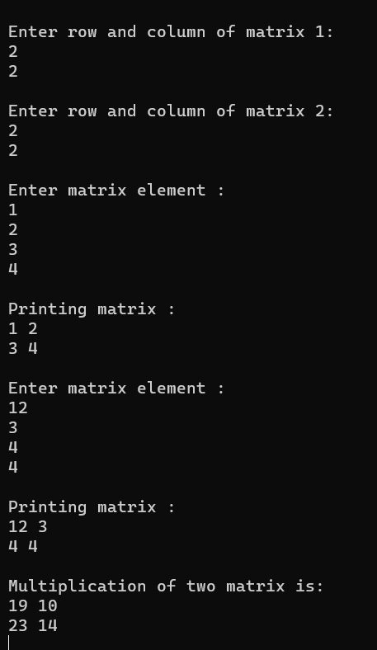

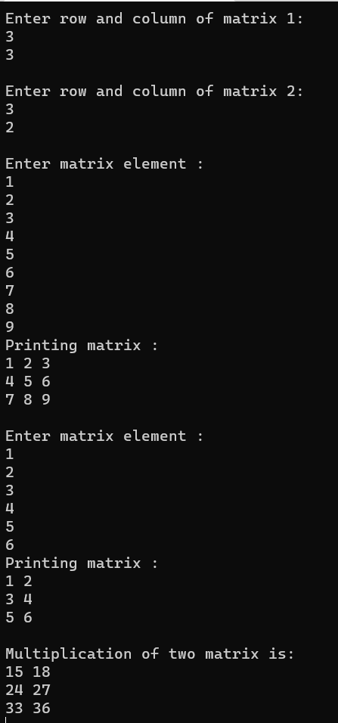

**Conclusion :**

Through this program we learn multiplication of matrix along with 2D array .

**Experiment No. 14**

Write a Program for deletion of an element from the specified location from Array.

**Aim :**

Deletion of an element from array

**Code :**

#include<stdio.h>

#include<conio.h>

void main()

{

int i,j=0,n,pos,arr[100];

//clrscr();

printf("Enter your array size:\n");

scanf("%d",&n);

printf("\nEnter your element is array:\n");

for(i=0;i<n;i++)

{

scanf("%d",&arr[i]);

}

for(i=0;i<n;i++)

{

printf("%d ",arr[i]);

}

printf("\nEnter your position to want to delete that element from array:\n");

scanf("%d",&pos);

if(pos>=n)

printf("Out of range !\nEnter valid position of element");

else

{

printf("\nYour element is deleted :%d",arr[pos]);

for(i=0;i<n;i++)

{

if(arr[pos]!=arr[i])

{

arr[j]=arr[i];

j++;

}

}

printf("\nPrinting Array after deletion process:\n");

for(i=0;i<n-1;i++)

{

printf("%d ",arr[i]);

}

}

getch();

}

**Output :**

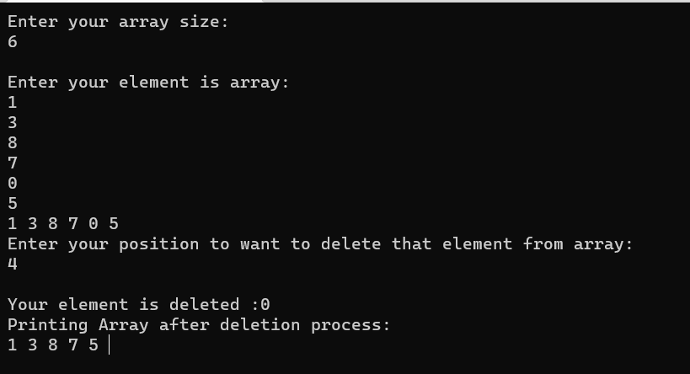

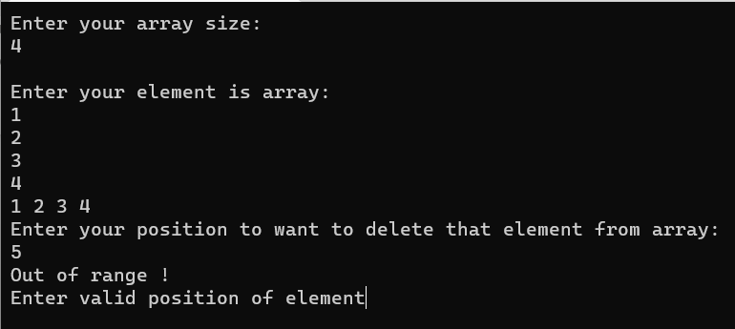

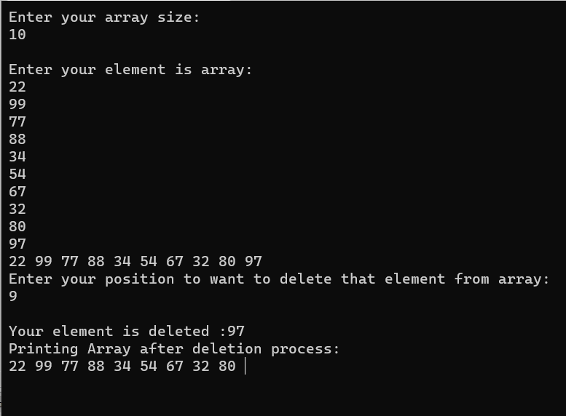

**Conclusion :**We studied and practice complex array through this program. How to delete an element from array .

**Experiment 15 :**

Write a C program using user defined functions to determine whether the given string is palindrome or not.

**Aim :**

Study of palindrome using user defined function.

**Code :**

#include<stdio.h>

#include<conio.h>

void main()

{

int n,rem,store,rev=0;

//clrscr();

printf("Enter your number :\n");

scanf("%d",&n);

store=n;

while(n>0){

rem=n%10;

rev=rev*10+rem;

n/=10;

}

if(store==rev)

printf("\nThe given number is palindrome");

else

printf("\nThe given number is not palindrome");

}

**Output :**

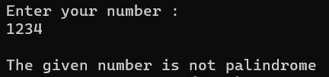

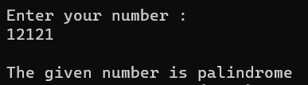

**Conclusion :**

We learn how to check whether a number is palindrome or not by using loop concept .

**Experiment 16 :**

Write C program to count the number of lines, words and characters in a given text .

**Aim :**

Study of string to find the number of lines, words and characters in a given text

**Code :**

#include<stdio.h>

#include<conio.h>

#include<string.h>

void main()

{

int count1=0,count2=0,count3=0,i=0;

char str[100];

printf("Enter a string/text :\n");

gets(str);

puts(str);

while(str[i]!='\0'){

if(str[i]=='\n'){

count1++;

}

else if(str[i]==' '){

count2++;

}

else if(str[i]!='\n' || str[i]!=' '){

count3++;

}

i++;

}

if(count3>0){

count1++;

count2++;

}

printf("\nNumber of lines is %d",count1);

printf("\nNumber of words is %d",count2);

printf("\nNumber of characters is %d",count3);

getch();

}

**Output :**

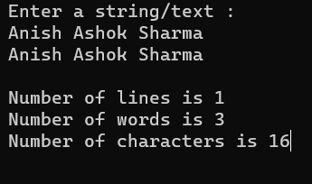

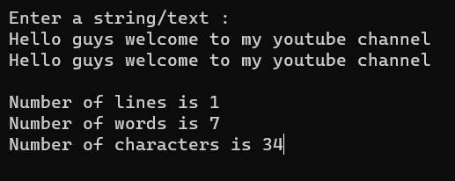

**Conclusion :**

Through this experiment we learn string and how it work .

**Experiment 17 :**

Write a program to swap two numbers using a function. Pass the values to be swapped to this function using the call-by-value method and call-by-reference method. Write algorithm and draw flowchart for the same.

**Aim :**

swap two numbers using a function

1. Pass By value
2. Call By Reference

**Algorithm :**

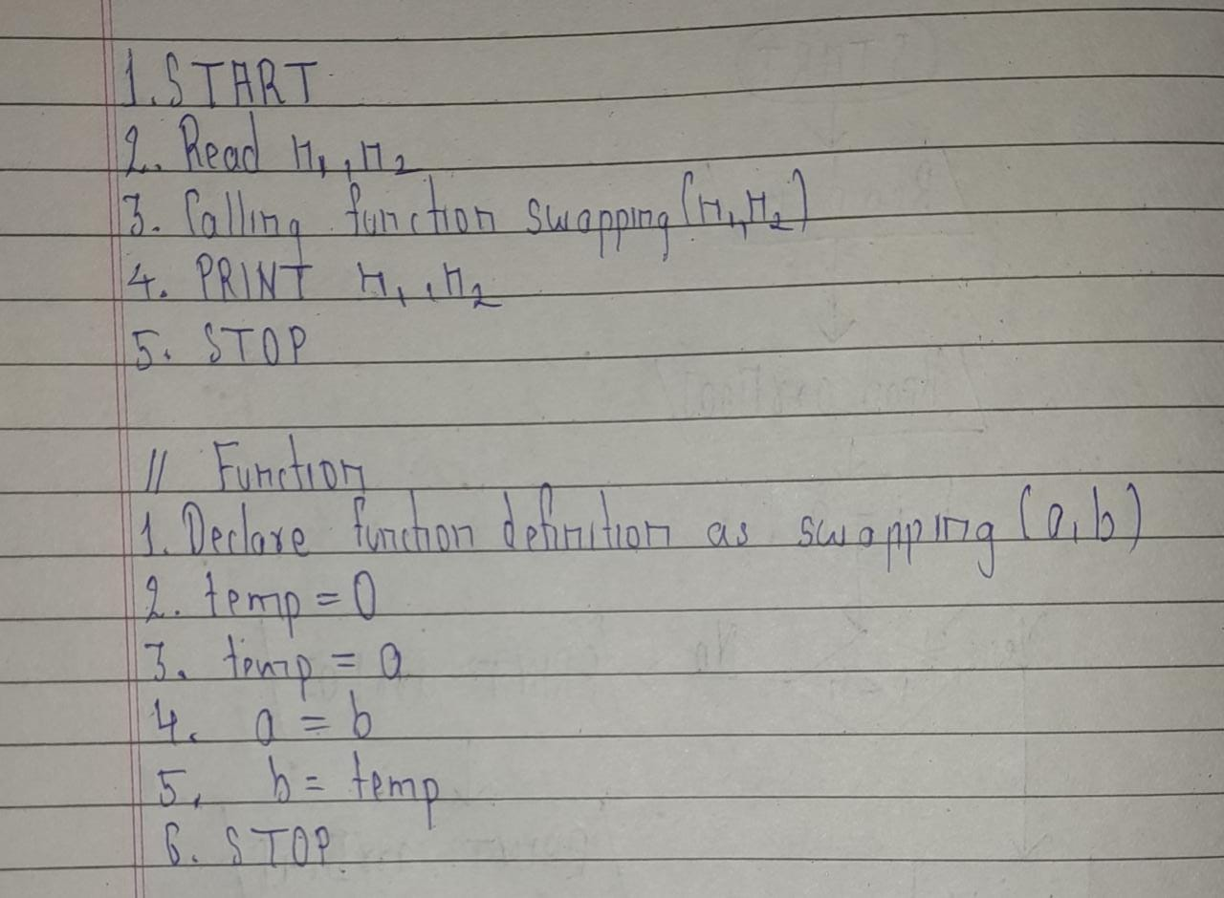

**Flowchart :**

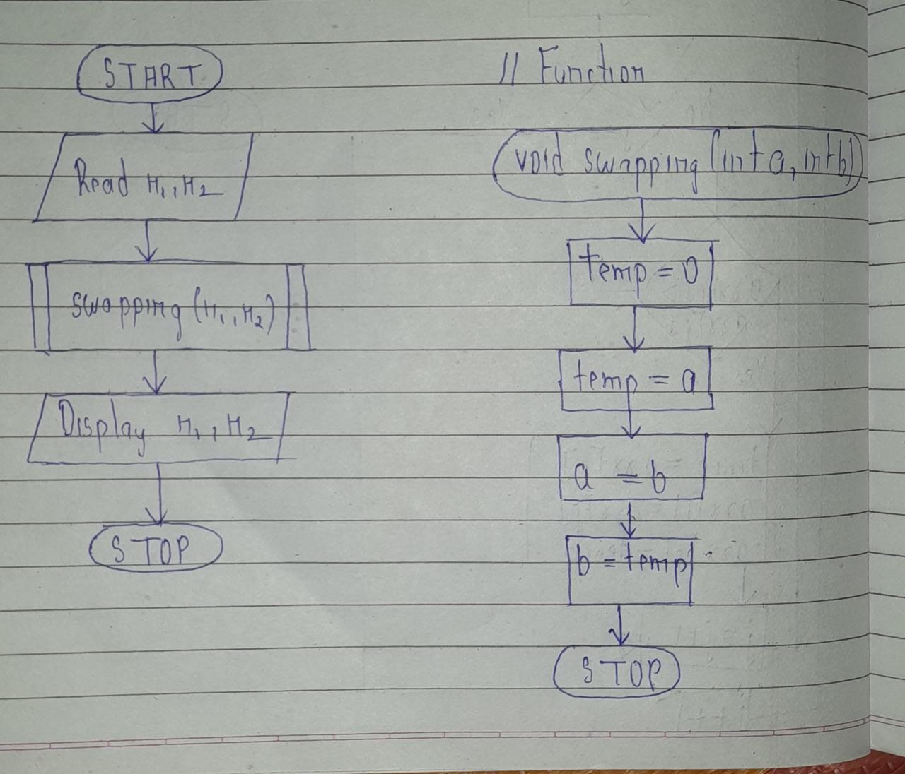

**Code :**

#include<stdio.h>

#include<conio.h>

#include<string.h>

void swapping(int a,int b)

{

int temp=0;

temp=a;

a=b;

b=temp;

}

void main()

{

int n1,n2;

printf("Call by value....\n");

printf("Enter two number :\n");

scanf("%d %d",&n1,&n2);

swapping(n1,n2);

printf("After swapping ,n1 and n2 be %d and %d respectively",n1,n2);

getch();

}

**Output :**

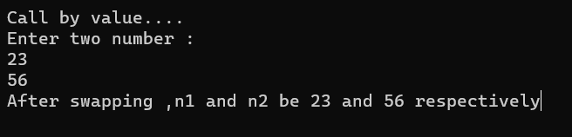

**2.**

**Algorithm :**

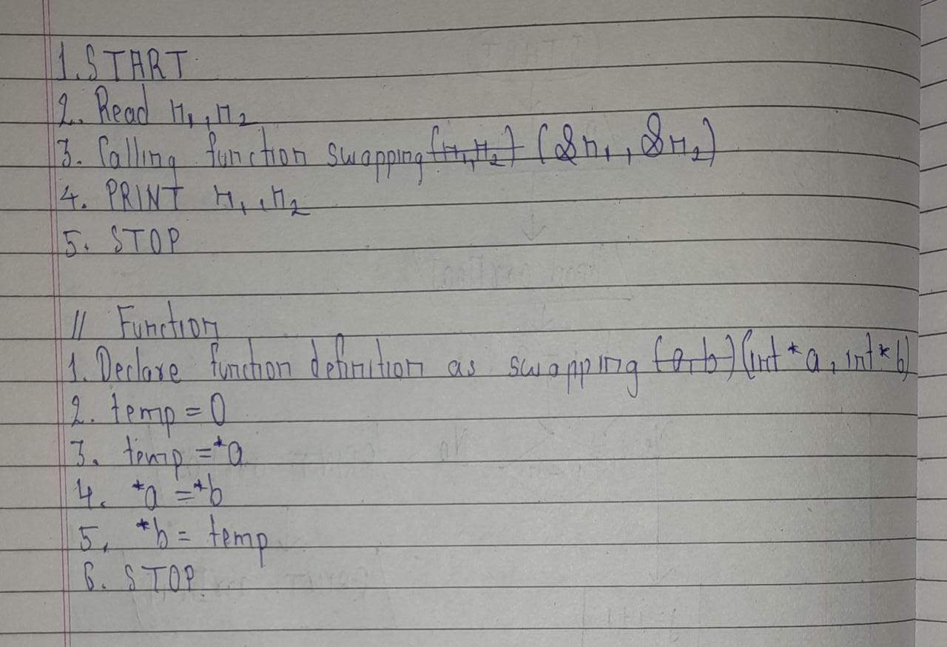

**Flowchart :**

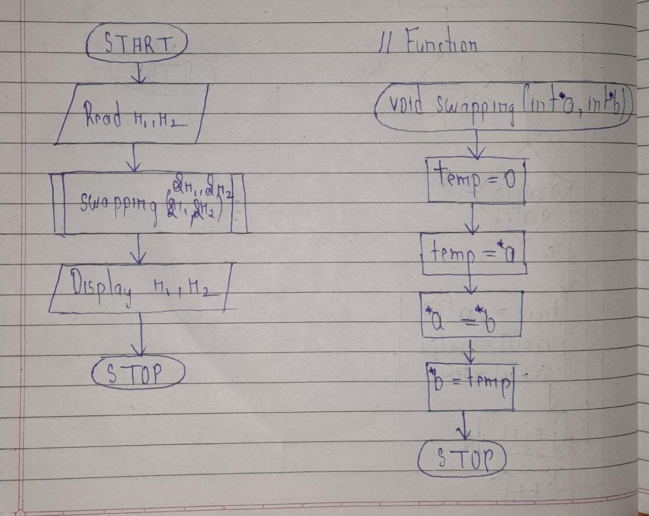

**Code :**

#include<stdio.h>

#include<conio.h>

#include<string.h>

void swapping(int *a,int *b)

{

int temp=0;

temp=*a;

*a=*b;

*b=temp;

}

void main()

{

int n1,n2;

printf("Call by reference....\n");

printf("Enter two number :\n");

scanf("%d %d",&n1,&n2);

swapping(&n1,&n2);

printf("After swapping ,n1 and n2 be %d and %d respectively",n1,n2);

getch();

}

**Output :**

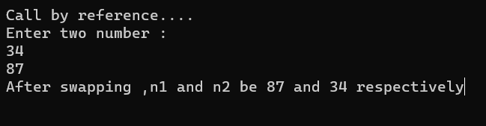

**Conclusion :**Through this experiment we learn pass by value and call by reference .

**Experiment 18 :**

Write a C program to find the length of the string using Pointer.

**Aim :**

Study of pointers in string.

**Code :**

#include<stdio.h>

#include<conio.h>

#include<conio.h>

void main()

{

char str[100];

char *ptr=&str,i=0,len=0;

//clrscr();

printf("Enter your string :\n");

gets(str);

puts(str);

while(*ptr!='\0'){

len++;

ptr++;

}

printf("Length of string using pointer is %d",len);

getch();

}

**Output :**

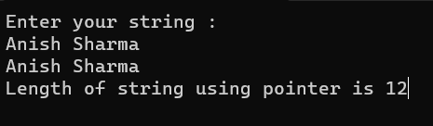

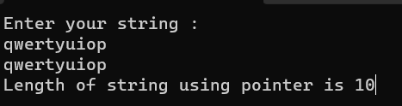

**Conclusion :**

We learn how to use pointer in string .

**Experiment 19:**

**Aim :**

Write a program to copy one array to another using pointer.

**Code :**

#include<stdio.h>

#include<conio.h>

void main()

{

int arr1[10],arr2[10],i,n;

int *ptr=&arr1;

//clrscr();

printf("Enter array size :\n");

scanf("%d",&n);

printf("Enter array element :\n");

for(i=0;i<n;i++){

scanf("%d",&arr1[i]);

}printf("\nPrinting array element:\n");

for(i=0;i<n;i++){

printf("%d ",arr1[i]);

}

for(i=0;i<n;i++){

arr2[i]=*ptr;

ptr++;

}

printf("\nPrinting copying array:\n");

for(i=0;i<n;i++){

printf("%d ",arr2[i]);

}

getch();

}

**Output :**

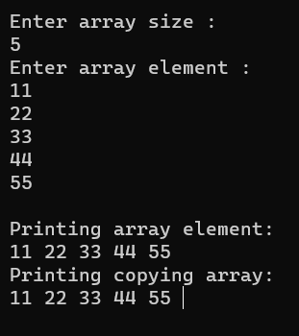

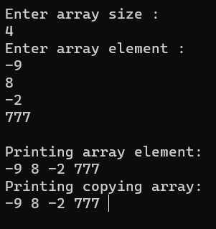

**Conclusion :**Through this experiment we learn use of pointers in array and how to copy one array element into another array.

**Experiment 20 :**

Write a program to compare two strings using pointers.

**Aim :**

Study of string using pointer .

**Code :**

**#include<stdio.h>**

**#include<conio.h>**

**#include<string.h>**

**void main()**

**{**

int i,equal = 0;

char string1[50],string2[50];

char *ptr1=string1;

char *ptr2=string2;

//clrscr();

printf("Enter The First String: ");

scanf("%s",string1);

printf("Enter The Second String: ");

scanf("%s",string2);

ptr1 = string1;

ptr2 = string2;

while(*ptr1 == *ptr2)

{

if ( *ptr1 == '\0' || *ptr2 == '\0' )

break;

ptr1++;

ptr2++;

}

if( *ptr1 == '\0' && *ptr2 == '\0' )

printf("\n\nBoth Strings Are Equal.");

else

printf("\n\nBoth Strings Are Not Equal.");

getch();

}

**Output :**

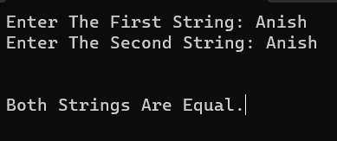

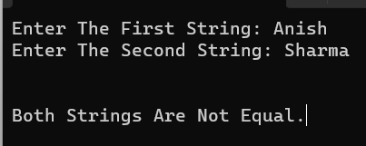

**Conclusion :**

Through this experiment we learn pointers in string and how to operate pointer in string.